100 irregular verbs

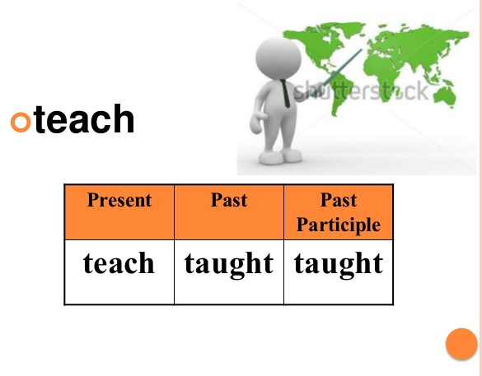

 | Portuguese | French | German | infinitive | past simple (+) | past participle
 | ser, estar | être | sein | to be | was/were | been
 | bater | battre | schlagen, gewinnen | to beat | beat | beaten
 | tornar-se | devenir | werden | to become | became | become
 | começar | commencer | anfangen | to begin | began | begun
 | curvar | couder | biegen, beugen | to bend | bent | bent
 | morder | mordre | beißen | to bite | bit | bitten
 | soprar, assobiar | souffler | blasen, wehen | to blow | blew | blown
 | quebrar | casser | brechen | to break | broke | broken
 | trazer | apporter | bringen | to bring | brought | brought
 | construir | construire | bauen | to build | built | built
 | comprar | acheter | kaufen | to buy | bought | bought
 | apanhar | attraper | fangen | to catch | caught | caught
 | escolher | choisir | wählen | to choose | chose | chosen
 | vir, chegar | venir | kommen | to come | came | come
 | custar | coûter | kosten | to cost | cost | cost
 | cortar | couper | schneiden | to cut | cut | cut
 | escavar | creuser | graben | to dig | dug | dug
 | fazer | faire | machen, tun | to do | did | done
 | desenhar | dessiner | zeichnen, ziehen | to draw | drew | drawn
 | beber | boire | trinken | to drink | drank | drunk
 | conduzir | conduire | fahren | to drive | drove | driven
 | comer | manger | essen | to eat | ate | eaten
 | cair | tomber | fallen | to fall | fell | fallen
 | dar de comer a, alimentar | alimenter | füttern | to feed | fed | fed
 | sentir | sentir | (sich) fühlen | to feel | felt | felt
 | lutar, brigar | lutter | kämpfen | to fight | fought | fought
 | encontrar | trouver | finden | to find | found | found
 | caber (em), compor | correspondre à, ajuster | jdm. passen, etw. anpassen | to fit | fit | fit
 | fugir | fuir | fliehen, flüchten | to flee | fled | fled
 | voar | voler | fliegen | to fly | flew | flown
 | esquecer | oublier | vergessen | to forget | forgot | forgotten
 | congelar, gelar | geler | frieren, erfrieren | to freeze | froze | frozen
 | obter, conseguir | recevoir | bekommen | to get | got | got
 | dar | donner | geben | to give | gave | given
 | ir | aller | gehen | to go | went | gone
 | crescer, cultivar | grandir, pousser | wachsen | to grow | grew | grown
 | pendurar | pendre | hängen, aufhängen | to hang | hung | hung
 | ter, possuir | avoir | haben | to have | had | had
 | ouvir | entendre | hören | to hear | heard | heard
 | esconder (-se) | (se) cacher | (sich) verstecken | to hide | hid | hidden
 | bater | battre, attraper | schlagen, treffen | to hit | hit | hit
 | agarrar, segurar | tenir | halten | to hold | held | held
 | magoar, ferir (-se) | blesser | verletzen | to hurt | hurt | hurt
 | manter. conserver | garder | behalten | to keep | kept | kept
 | ajoelhar-se | s‘agenouiller | knien | to kneel | knelt | knelt
 | saber, conhecer | savoir | wissen | to know | knew | known
 | pôr, colocar | mettre, pondre (oeuf) | legen (Ei), hinlegen | to lay | laid | laid
 | liderar | diriger, mener, guider | leiten, anführen | to lead | led | led
 | partir, deixar, sair | quitter, partir | verlassen | to leave | left | left
 | emprestar | prêter | (ver)leihen | to lend | lent | lent
 | deixar | laisser | lassen | to let | let | let
 | estar deitado | être allongé | liegen | to lie | lay | lain
 | iluminar, acender | allumer | anzünden, beleuchten | to light | lit | lit
 | perder | perdre | verlieren | to lose | lost | lost
 | criar, elaborar, fazer | faire | herstellen | to make | made | made
 | significar, querer dizer | signifier, vouloir dire | bedeuten | to mean | meant | meant
 | encontrar (-se), reunir (-se) | rencontrer | treffen | to meet | met | met
 | pagar | payer | bezahlen | to pay | paid | paid
 | pôr, colocar, meter | mettre | hinstellen, hinlegen | to put | put | put
 | ler | lire | lesen | to read | read | read
 | cavalhar, andar de (bicicleta etc.) | faire du cheval | reiten (Pferd),  fahren (Fahrrad) | to ride | rode | ridden
 | tocar | sonner | klingeln, läuten | to ring | rang | rung
 | elevar-se, subir, levantar-se | lever | aufgehen, auf(er)stehen | to rise | rose | risen
 | correr | courir | laufen | to run | ran | run
 | dizer | dire | sagen | to say | said | said
 | ver | voir | sehen | to see | saw | seen
 | vender | vendre | verkaufen | to sell | sold | sold
 | enviar, mandar | envoyer | schicken | to send | sent | sent
 | dispor, pôr, ajustar, instalar | mettre, installer | hinlegen, hinstellen | to set | set | set
 | sacudir, tremer (apertar a mão) | agiter | schütteln | to shake | shook | shaken
 | brilhar | briller | scheinen, glänzen | to shine | shone | shone
 | fuzilar, atirar (ferir com tiro, ferir por bala), chutar | abattre (tirer, fusiller, blesser par balle) | (er-)schießen | to shoot | shot | shot
 | mostrar | montrer | zeigen | to show | showed | shown
 | fechar | fermer | schließen | to shut | shut | shut
 | cantar | chanter | singen | to sing | sang | sung
 | afundar (-se) | couler, sombrer | untergehen | to sink | sank | sunk
 | sentar (-se) | être assis | sitzen | to sit | sat | sat
 | dormir | dormir | schlafen | to sleep | slept | slept
 | escorregar, deslizar | glisser | rutschen | to slide | slid | slid
 | falar | parler | sprechen | to speak | spoke | spoken
 | gastar (dinheiro)  passar (tempo) | dépenser (argent)  passer (temps) | ausgeben (Geld),  verbringen (Zeit) | to spend | spent | spent
 | espalhar, estender | répandre | ver-, ausbreiten | to spread | spread | spread
 | estar de pé | se tenir, être debout | stehen | to stand | stood | stood
 | roubar | voler | stehlen | to steal | stole | stolen
 | colar | coller | kleben | to stick | stuck | stuck
 | nadar | nager | schwimmen | to swim | swam | swum
 | tomar | prendre | nehmen | to take | took | taken
 | ensinar | enseigner | lehren, unterrichten | to teach | taught | taught
 | rasgar | déchirer | (zer)reißen | to tear | tore | torn
 | contar | raconter | erzählen | to tell | told | told
 | pensar, achar | penser | denken | to think | thought | thought
 | lançar, atirar, mandar | lancer | werfen | to throw | threw | thrown
 | compreender, (entender) | comprendre | verstehen | to understand | understood | understood
 | acordar | se réveiller | aufwachen | to wake up | woke up | woken up
 | vestir, usar | porter | tragen (= Kleidung) | to wear | wore | worn
 | ganhar, vencer | gagner | gewinnen | to win | won | won
 | escrever, anotar | écrire | schreiben | to write | wrote | written

Other irregular verb forms: modals / substitutes

 |  | present  simple | past  simple | present perfect simple
 | F: savoir faire qc.  G: können  P: ser capaz de fazer uma coisa | can  am able to  are able to  is able to | could  was able to  were able to | ---  have been able to  has been able to
 | F: avoir la permission de faire qc.  G: dürfen  P: poder fazer uma coisa | may  am allowed to  are allowed to  is allowed to | ---  was allowed to  were allowed to | ---  have been allowed to  has been allowed to
 | F: être obligé de, falloir, devoir  G: müssen  P: ser obrigado a fazer uma coisa, dever | must  have to  has to   negative form:  don’t have to  doesn’t have to | ---  had to   negative form:  didn’t have to | ---  have had to  has had to

